Project Report

|  |  |
| --- | --- |
| Project Title | Problem Manage a Server Outage Scenario & an Issue & Change Request Management System |
| Qualification Name (NICF) | Advanced Certificate in Software Applications (Development and Deployment) |
| Product Name | NICF-Capstone Project using Java |
| Module Name (NICF) | NICF-Capstone Project using Java |

|  |  |  |  |
| --- | --- | --- | --- |
| Student name | | Assessor name | |
| Wildan Luqmanul Hakim | |  | |
| Date issued | Completion date | | Submitted on |
| 10 October 2022 | 21 October 2022 | | 21 October 2022 |
|  | |  | |
| Project title | Student Registration Form Development | | |

|  |
| --- |
| Learner declaration |
| I certify that the work submitted for this assignment is my own and research sources are fully acknowledged.    Student signature: Date: 21 October 2022 |

Content

1. Project background
2. Project Objectives
3. Project Requirement Specifications
4. Task 1
5. Task 2
6. Task 3
7. Task 4
8. Task 5
9. Task 6

Project Background

This project is made for summative assessment in the 7 Capstone Project-Web Development module, this project is entitled " Problem Manage a Server Outage Scenario & an Issue & Change Request Management System" with the qualification name " Advanced Certificate in Software Applications (Development and Deployment)”. This project is a continuation of the previous modules.

'ABC Jobs Pte Ltd' has approached you as a website developer to test their software developer community portal. The purpose of this project is to manage the website that has been created, especially in managing problems, how problems with the website can occur and how to solve them. You should also investigate how to streamline the incidence and enhancement management to prevent such problems from recurring.

Project Objective

**Project Outcomes & Deliverables**

You should perform all the tasks in the Project Task List and prepare the following  
during the project:

* Briefly explain different types of testing which you will undertake
* Test Schedule Document
* Phase test plan
* Execute test scripts and verify the results
* Prepare a Project Report as per pre-defined template
* Prepare a Project Presentation as per pre-defined template
* Prepare a Testing Document

**Scope of the Project:**

* Explain principles of problem management across its lifecycle.
* Use various tools, process and technologies to facilitate problem identification, investigation, analysis & resolution
* Explain various steps to investigate & diagnose problems.
* Prioritize & Categorize change requests.
* Prepare a solution to address the root cause of the problem.
* Document & monitor the problems
* Explain best practices in documenting problems.

Tools & platform used

1. Draw.io

draw.io is designed for Confluence teams, offering unique features like real-time Confluence-native collaborative editing.

1. Microsoft Word

Microsoft word is a word processing software application primarily used for creating documents in different formats

1. Microsoft Power Point

Microsoft PowerPoint is a program that is included in the Microsoft Office suite. It is used to make presentations for personal and professional purposes.

Project Requirements Specifications

* Functional Requirements

**Software Programmer (Users)**

|  |  |  |
| --- | --- | --- |
| **No** | **Page Name/ Function Name** | **Requirement** |
| 1 | Registration | This page is used for users to register to create an account so they can login to the website |
| 2 | Login user | This page is used by users to enter the website with an account that was previously registered |
| 3 | Forgot password | This page is used by the user to reset their password if the user forgets the password |
| 4 | Search user | This page is used by the user to search for other users |
| 5 | Update/Edit profile page | this page is used to change the profile of the user |
| 6 | Change password | This page is used by the user if the user wants to change the account password |
| 7 | Posting Thread | This page is used by users to create post threads as a place to share, ask questions, or others |
| 8 | Comment Thread | Used to comment on other user's thread posts or our thread posts |
| 9 | Apply job | This page is used by the user to apply for a job if the user does not have a job |

**Administrator**

|  |  |  |
| --- | --- | --- |
| **No** | **Page Name/ Function Name** | **Requirement** |
| 1 | Login admin | This page is used by the admin to enter the website as administrator |
| 2 | Dashboard | This page is used by admins to manage users and jobs such as adding, changing or deleting users and jobs, and send bulk emails. |
| 3 | Add user | This page is used by admin to add new user |
| 4 | Edit user | This page is used by admin to edit data user |
| 5 | Delete user | This page is used by admin to delete user |
| 6 | Posting jobs | This page is used by admins to post or add new jobs to the website |
| 7 | Accept user for job | This page is used by the admin to accept or reject job applications from users |

* Non-Functional Requirements

|  |  |  |
| --- | --- | --- |
| No | Requirements | Purpose |
| 1 | Performance | Ensure the application will perform well under the expected workload. |
| 2 | Availability | Provides interesting and useful features for users |
| 3 | Security aspect | Secure users data from cyber attack |
| 4 | Database backup and recovery | To protect the database from data loss and to rebuild the database after data loss. |
| 5 | Compatibility | Defines how one system in the same environment can coexist with another. |
| 6 | **Localization** | Defines how well a system or one of its components fits into the context of the local market. |
| 7 | Scalability | Determines the maximum workloads at which the system will still meet performance requirements. |

Task 1

Task Statement:

1. Briefly explain principles of problem management with an example across its  
   lifecycle.
2. Include it as part of Project Presentation.

Solution:

* What is Problem Management?

Problem management is a collection of processes and actions that govern the lifecycle of any problems that may arise in an IT service. It also employs preventative techniques to identify root causes and avoid problems.

The goal of problem management is to prevent future occurrences of existing problems or incidents. It also entails determining the best solution to the underlying problem. If the problem cannot be avoided, an effective problem management procedure will assist in mitigating its negative effects on the business.

* Principles of Problem Management
  1. Problem Identification

An incident report or an analysis of an existing incident can detect a problem. It is most likely when the cause of an occurrence or series of incidents is unknown. Proactive problem detection is critical for preventing future service interruptions.

* 1. Problem Logging

Problems must be documented for future reference. The type, description, associated incidents, category, user information, status, resolution, and closure of the problem must all be documented. This data is required to identify and manage known issues in a database.

* 1. Problem Investigation

When conducting a root cause analysis, the severity and urgency of the problem must also be considered. A common investigation technique is to search the Known Error Database (KEDB) for similar issues. The best course of action to address the issue is then chosen.

* 1. Resolution

Following the identification and resolution of the problem, the solution can be implemented using a standard change procedure. It is also critical to ensure the restoration of service. To solve the problem permanently, a new change must be implemented. Change Management is in charge of assessing, planning, and carrying out changes.

* 1. Review

It is critical to review the problem's resolution and its impact on the business at this stage, as well as conduct a risk assessment. This ensures that the problem-solving process is efficient and that it is constantly improved for the future. This review has been documented and distributed to the appropriate teams and individuals.

* Problem Management Example

1. Problem Identification

The root cause of this development process error is " org.apache.jsp.WEB_002dINF.views.register_jsp”

Screen shot:

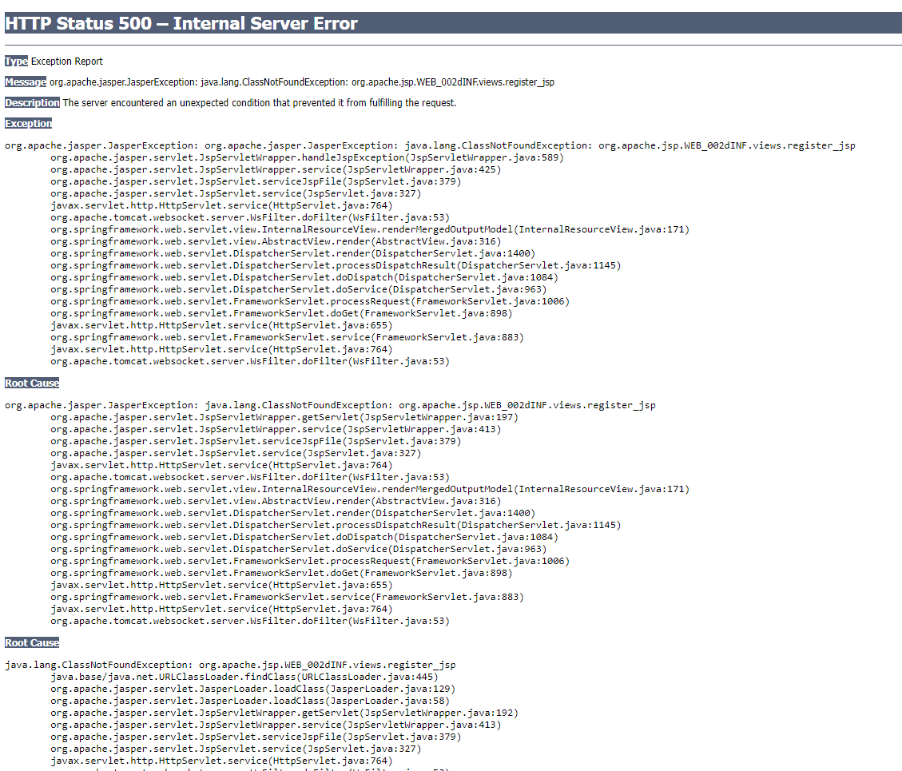

1. Problem Logging

|  |  |  |  |
| --- | --- | --- | --- |
| No | Where | Date | Root Cause |
| 1 | Register.jsp | 4 October 2022 | The root cause of this development process error is " org.apache.jsp.WEB_002dINF.views.register_jsp” |

1. Problem Investigation

Possibly because there is a typo in the element or object.

1. Resolution

Open and check register.jsp then change the typo element from <form> to <form:form>



Task 2

Task Statement:

1. Explain briefly various tools, process & technologies to facilitate problem  
   identification, investigation, analysis & resolution.
2. Include it as part of Project Presentation.

Solution:

* Problem Identification

Techniques = Issue Tracking System

Tool = Excel Sheet

Creating a tracking document template in Excel is a useful tool for problem identification.

Process:

1. Receive a problem report
2. Verify the problem
3. Logging the problem issue
4. Resolving the problem
5. When it’s resolved, it will be remarked as resolved in the issue tracking system

|  |  |  |  |  |  |  |  |  |  |  |
| --- | --- | --- | --- | --- | --- | --- | --- | --- | --- | --- |
| Issue Identification and Tracking Document | | | | | | | | | | |
| Created By: | | | Wildan Luqmanul Hakim | | Last Update By: Wildan Luqmanul Hakim | | |  | | |
| Date Created: | | | 15 October 2022 | | Last Revision Date: 16 October 2022 | | |  | | |
| Issue No. | Issue Description | Issue Type | Identified By | Date Identified | Issue Assigned To | Target Resolution Date | Priority | Status | Date Resolved | Resolution Description |
| 1 | Post job not connected to database | Technical Issues | Software Tester Team | 15 October 2022 | Software Development  Team | 19 October 2022 | High | Resolved | 16 October 2022 | Adding the service method to the controller to ensure proper functionality |

* Problem Investigation

Techniques = Root Cause Analysis

Tool = Fish Bone

Process:

1. Define the problem statement
2. Find the root cause
3. Fix the root cause
4. Finalize solution

* Problem Resolution

Techniques = Known Error Database

Tool = Excel Sheet

Creating a tracking document template in Excel is a useful tool for problem identification.

Process:

1. Recording known errors
2. Make a known error record that includes the symptoms and resolution information.
3. Obtaining known error records
4. Check KEDB and apply the fix
5. Removal of known error records
6. Implemented a permanent solution

Task 3

Task Statement:

1. Explain briefly various steps you will take to investigate & diagnose problems.
2. Include it as part of Project Report.

Solution:

* Investigate Problem

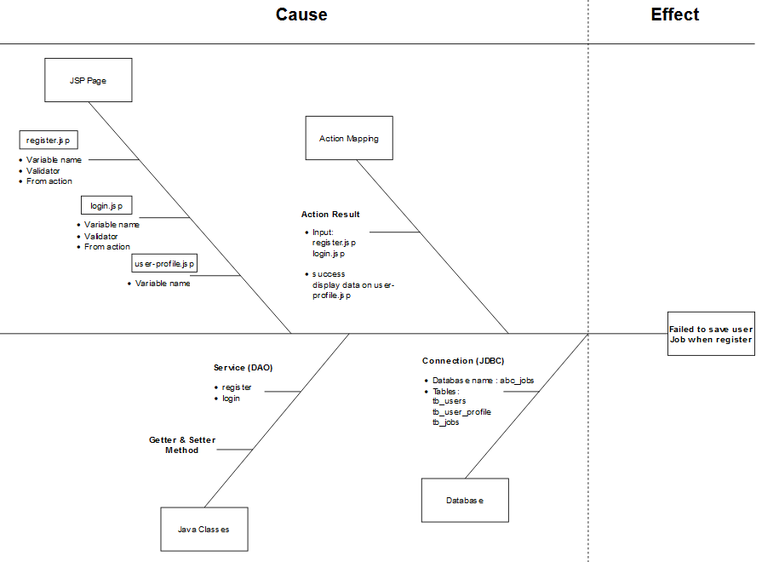

* Diagnose Problem

Diagnosing the root cause:

* “There is no value present.”
* It's most likely because no value is present in the jsp form for job.

1. Task 4

Task Statement

1. Briefly explain how you will prioritize, categorize incident & change requests for  
   the application according to their severity, frequency or potential implication.
2. Include it as part of Project Presentation.

Solution

Prioritize and Categories problems:

* Tier 1: Low priority issues  
  The first tier is for basic or minor problems.

Example: Some words on the website have typos.

* Tier 2: Medium priority issues

The second tier is the major problems

Example: The register page is broken and does not save to the database.

* Tier 3: High priority issues

The third tier is the critical problems

Example: The website server is down, and a hacker has attacked it.

1. Task 5

Task Statement

1. Explain about solution you will implement to address the root cause of the  
   problem and avoid their reoccurrence.
2. Include it as part of Project Presentation.

Solution

Case problem:

User thread is not displayed properly after user created a post thread

Solution:

1. Examine the controller and service method responsible for retrieving the post thread database.
2. Correct the appropriate function/method.
3. Evaluate the functionality
4. Once the problem has been resolved, record it in the KEDB table to prevent it from recurring.

|  |  |  |  |  |  |  |
| --- | --- | --- | --- | --- | --- | --- |
| Known Error Database | | | | | | |
| **Ticket no.** | Issue Description | Issue Type | Root Cause | Workaround | Status | Date Resolve |
| 1. | User thread not fetched properly | Technical Issues | Kode DAO yang diperlukan untuk terhubung ke database tidak ada. | fix the DAO code connected to the database | Resolved | 15 October 2022 |

1. Task 6

Task Statement:

1. Explain briefly any systems you will implement.
2. Include it as part of Project Presentation

Solution

Systems that will be implemented:

1. Apply Job

Users (Software Programmer)

1. User Job Page

* Displaying the user's job

1. List Job Page

* Listing all of the jobs available on the website
* This page is viewable by all website visitors.

1. Apply Job functionality

* Users who have logged in to the website and do not have a job can apply for a job

1. Apply Job history

* History of Users who have applied for one or more jobs on the website
* displays the status of the user's job application, the user can find out that the job application was rejected or accepted

1. Search Job functionality

* Users can search for available jobs on the website
* Job search can be searched using keywords: job name, company name, job level or job time

Admin

a. Manage jobs

* To manage jobs available on the website such as adding jobs, changing jobs, deleting jobs and accepting or rejecting user job applications

1. Threads
2. List Thread

* List of all user threads on the website

1. Search Thread

* Users can search for their own threads or other threads by using the keywords thread title, thread first tag and thread second tag

1. Post Thread

* Users who have logged in to the website can create a post thread

1. Edit Thread

* Users can edit their own thread

1. Read Thread

* Users can read and see the details of the post thread

1. User Thread

* List post threads from logged in users

1. Comment Thread

* User comments to your own thread or someone else's thread

1. Task 7

Task Statement:

1. Briefly explain any best practices and industry standards in documentation  
   related to problem management.
2. Include it as part of Project Report.

Solution

Best Practices and Industry Standards for Problem Management:

1. Solved problems need to be recorded in Known Error Database

When you have used your investigative skills to identify the root cause of a problem, you have a 'Known Error.' Incidents and known problems should be kept separate from the problem. Simply put, it allows for more dynamic categorization. This allows you to reclassify an error after an investigation.

1. Clients should be separate from the person handling the incident

It's easy to keep everything in a hold-all. When handling a call, look for a location that can function as a one-stop shop. Separating problems from incidents and logging them in their own dedicated space, on the other hand, can aid in process improvement.

1. Having a problem manager

Having someone in charge of Problem Management can significantly improve your overall process.

1. Let your operators contribute: Share knowledge

Having a manager is advantageous, but collaboration is essential. Allow your team to contribute to Problem Management so that they can make the most of their knowledge and experience. This can add some interesting variety to their roles and can help you identify a root cause more quickly if you have keen colleagues who are good at detecting issues.